Artificial-windpipe surgeon committed misconduct
David Cyranoski 21 May 2015

Papers authored by Paolo Macchiarini misrepresented success of pioneering procedure.
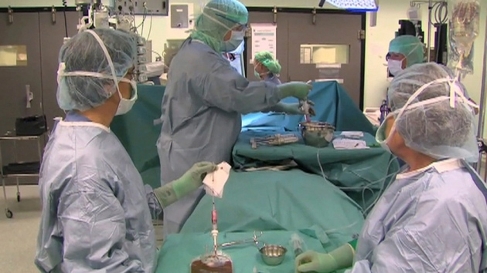
Surgeon Paolo Macchiarini transplanting a synthetic trachea in 2011.
The investigator found that six published papers authored by Paolo Macchiarini, a thoracic surgeon at the Karolinska Institute in Stockholm, had misrepresented data from recipients of the artificial windpipes, or tracheas. The papers made the pioneering transplant operation sound more successful than it was, said the investigator, who was commissioned by the prestigious Karolinska Institute to examine Macchiarini's clinical procedures.
The investigation also found that two of the papers described operations that had not received the necessary ethical approval (Lancet 378, 1997–2004 (2011) and Biomaterials 34, 4057–4067; 2013), and that a seventh paper, also authored by Macchiarini, reporting transplantation of artificial oesophagi into rats (Nature Commun. 5, 3562; 2014), had misrepresented results, too.
Macchiarini told Nature that he would not comment on the investigation results, which are reported in Swedish, until he had seen an English version of the report. The translation is due to be released next week. In November 2014, when the investigation was under way, he told Nature that he welcomed the investigation and that he was confident that “there is nothing suspect, unethical, inflated or misleading about anything I have done or reported”.

Bright spot
He will now have two weeks to formally respond to the 39-page report, which was written by Bengt Gerdin, a general surgeon and professor emeritus at Uppsala University in Sweden.
Macchiarini’s research had been hailed as a bright spot in the field of regenerative medicine, which has been frustratingly slow to deliver on its promise of allowing synthetic materials to act as replacements for natural organs. His procedure involved bathing a specially made polymer shaped like a trachea in stem cells taken from the transplant-recipient’s bone marrow. The idea was that when this was transplanted to replace a damaged trachea, the cells would form the necessary type of tissue and create a seal with the surrounding tissue.
Macchiarini has put such artificial tracheas into eight people. The papers under investigation relate to just three of them, and report that there were some signs that the synthetic tracheas had successfully integrated. Two of those transplant recipients have since died, and one spent time in intensive care after the procedure. Macchiarini has previously told Nature’s news team that the problems faced by the patients were unrelated to the transplants.
The investigation began after four physicians at Karolinska who were involved in the care of those three patients filed complaints. The physicians — Karl-Henrik Grinnemo, Matthias Corbascio, Thomas Fux and Oscar Simonson — provided medical records that they alleged to be at odds with the published results, and called into question the paper on the rat model.

Deliberate misrepresentation
In compiling the report, Gerdin says, he compared what was in the medical records with what was in the publications and tried to avoid matters of interpretation that would become “a quarrel between scientists”. He says that he stuck to facts such as whether the medical records showed evidence of a follow-up at the intervals claimed by the papers.
In some instances, publications claimed improvement in patients even though there was no evidence of an examination. “This is falsification,” says Gerdin. Speaking of Macchiarini, he adds: “The basic rule in science is to have all reports documented, but he doesn’t have them.”
In the rat-model paper, Macchiarini reported weight-gain data and computed-tomography (CT) data that suggested that the graft was more successful in the rats than it actually was, says Gerdin.
Gerdin concludes that the misrepresentations were deliberate. “If there is a mistake once, you might think it is random. If it happens several times, you begin to question whether it really is random,” he says.
Nature’s news team contacted two of the journals that published the papers (the journals were not the focus of the investigation).“We take all concerns regarding published research extremely seriously," says Joerg Heber, executive editor of Nature Communications, which published the rat-model paper. "It is important that we carefully consider the report and the responses of the various parties in order to ensure that we act appropriately. We cannot comment further at this stage.” (Nature Communications is published by Nature Publishing Group, which also publishes Nature).
A spokesperson for The Lancet, which published two of the seven papers (Lancet 378, 1997–2004 (2011) and Lancet 379, 943–952; 2012), said that the journal's editors were aware that the investigation had concluded, but would wait to comment until the English translation was released.

